## Brief

This document is the user manual for telink zigbee gateway controller tool, and note that only the generic step is shown here, please refer to “AN_19052900-E_Telink Zigbee SDK Developer Manual.pdf” for more information.

## System Architecture

Serial port

Zigbee Gateway

Computer B

Computer

Telink Zigbee

Gateway Controller Tool

## Step-by-Step Guide

Step 1: Open the port

1. Select the port number, and other options can use the default value.
2. Click the “open” button and open the port.
3. When the port is opened, the tool sends a “get joined nodes” command automatically.

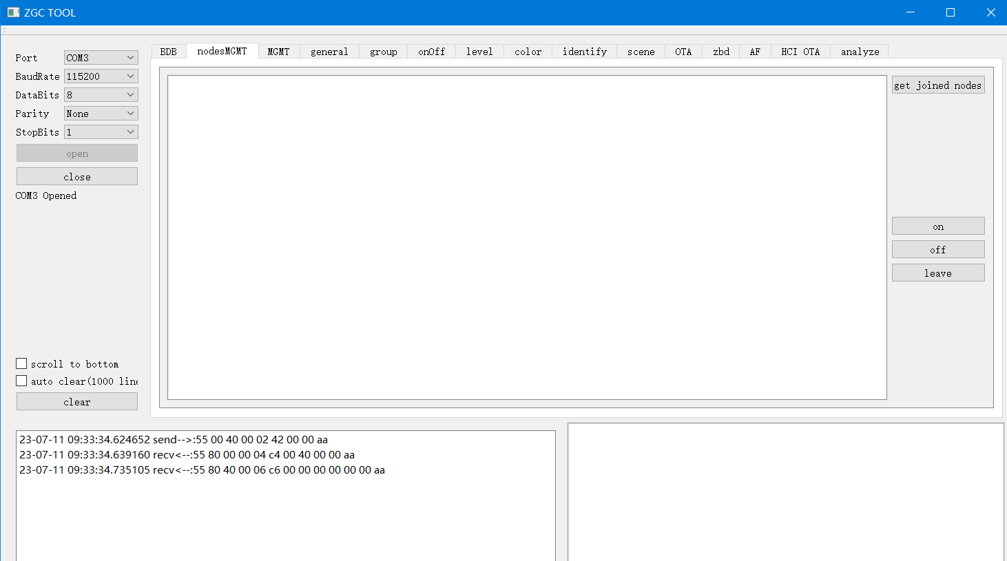

Step 2: Set the channel

1. Switch to the “BDB” page
2. Select a channel you want to use and click the “Set Channel” button.

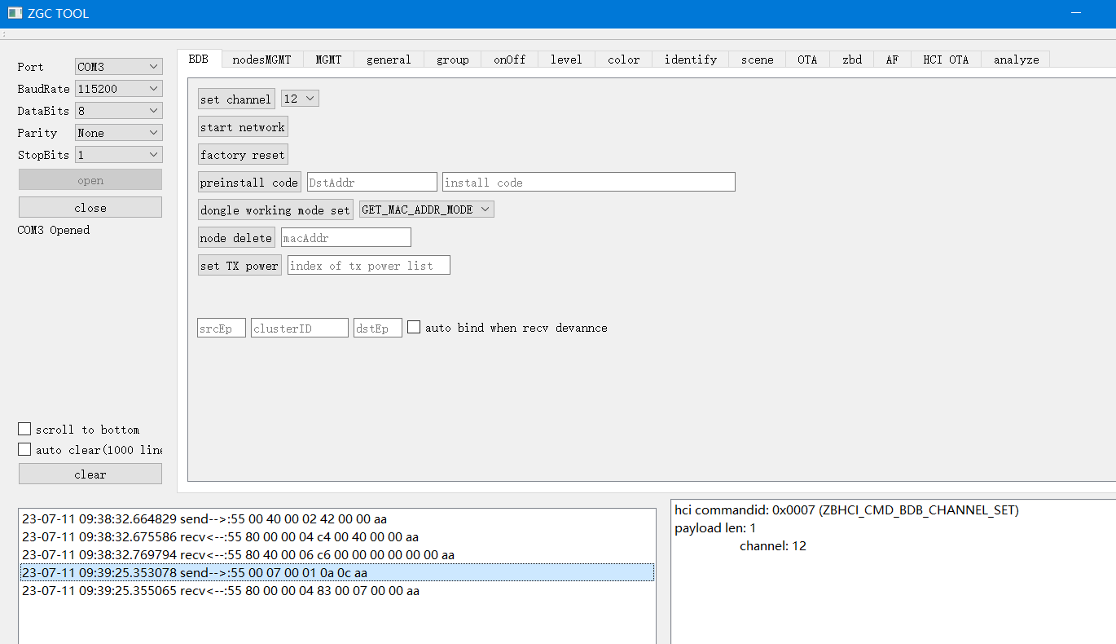

Step 3: Start the network

1. Click the “Start Network” button to start the network

Step 4: Set the permit join interval

1. Switch to the MGMT page
2. Fill the address and interval
3. Click the “Permit Join” button

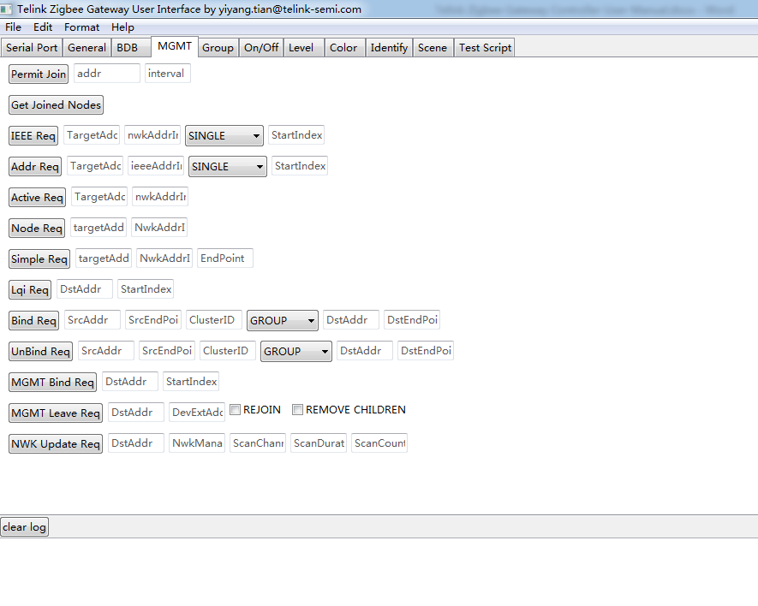

Step 5: Power on the Zigbee device to join the network before the permit join interval expires, and then you can use other commands to control the device.

## Auxiliary Function

### AF Test

Generally, we use the AF command to test large networks. Switch to the “AF” page, choose the address mode, and fill the test interval.

If you choose broadcast mode, then the gateway will broadcast the toggle command at the setting interval. If you choose the unicast mode, the gateway will unicast ZCL on or off command to every node at the setting interval.

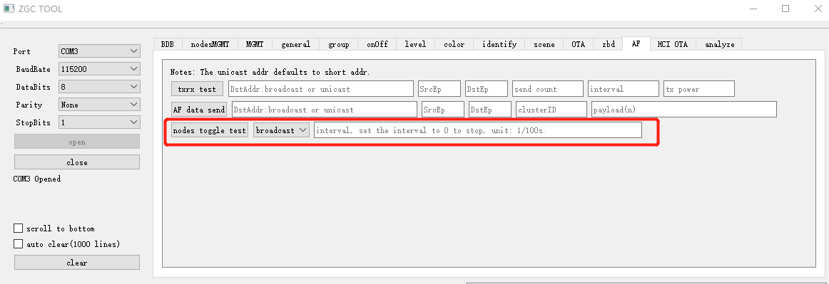

### Analyse

Every time you open the tool, all the packets are saved in a folder, named with the current timestamp. The folder is in “userdata” folder which is under the [installation directory](javascript:;).

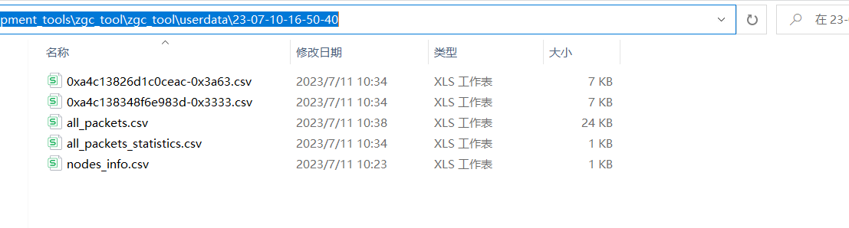

If you want to analyse the loss rate of the nodes, you can switch to the “analyze” page. Then click the “Start Analyze” button.

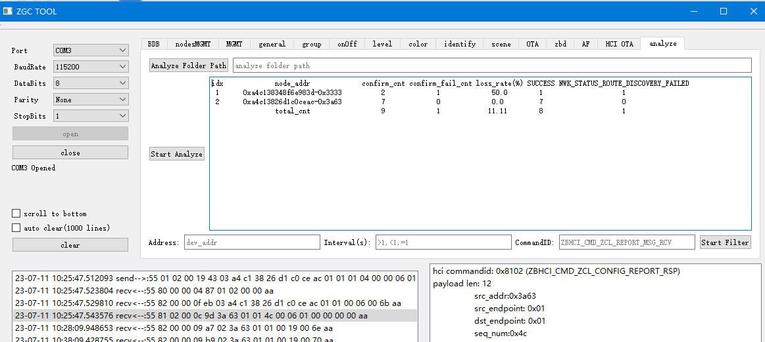

Fill the folder path you want to analyse in the text box. If you want to parse the contents of the current folder, you may not fill the folder address. The packet loss rate of each node is measured based on the confirm packet feed back by the gateway. The packet loss reasons for each node are also listed below.

File content:

“all_packets.csv”: All the packets sent or received by the tool.

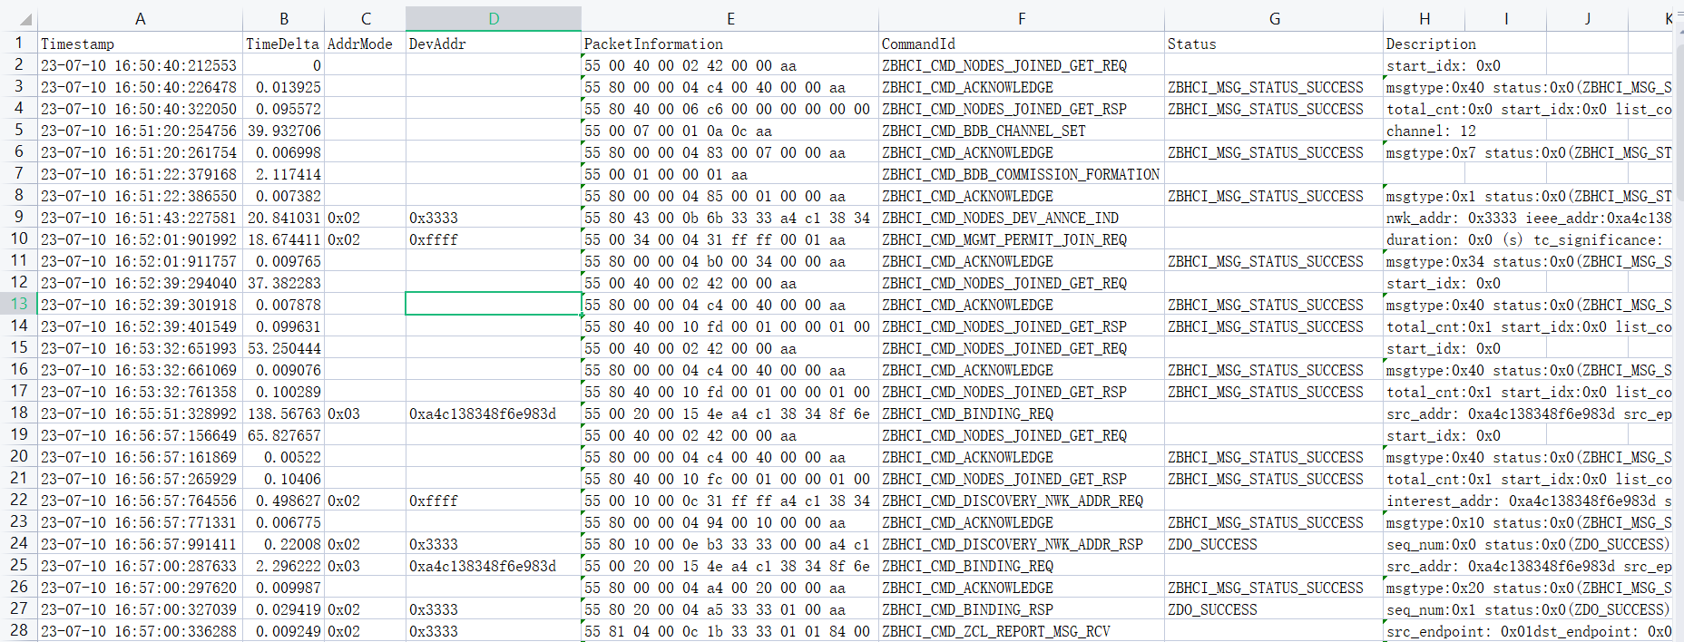

“nodes_info.csv”: The information of the joined nodes.

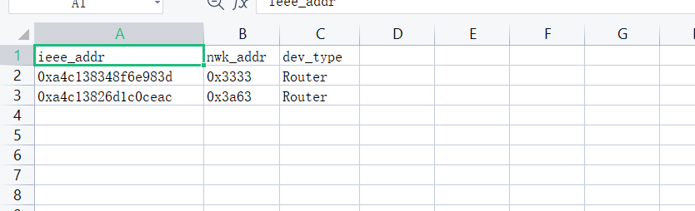

“all_packets_statistics.csv”: The analyse result.

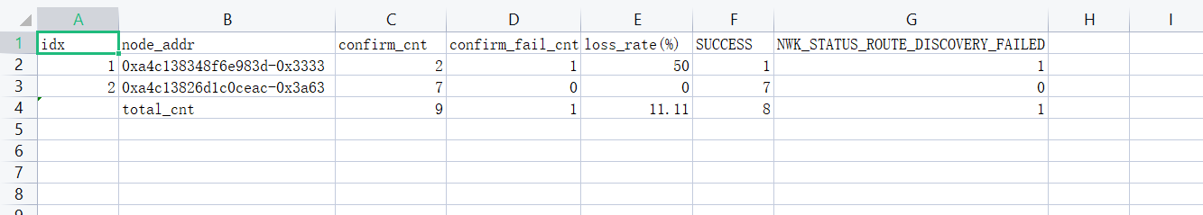

“0xa4c138348f6e983d-0x3333.csv”: All the packets related to one specified node.

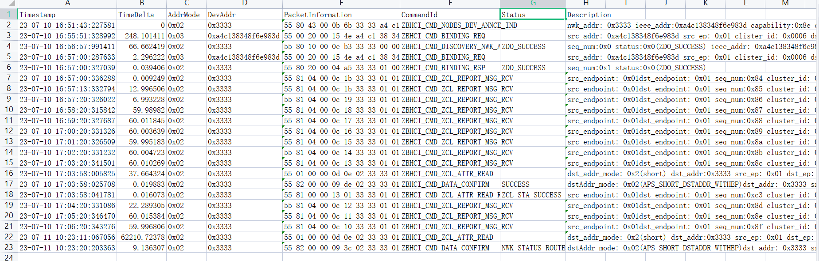

## Notes

1). If you want to test the network for a long time, you had better to enable the “auto clear” to prevent the tool from becoming slow.

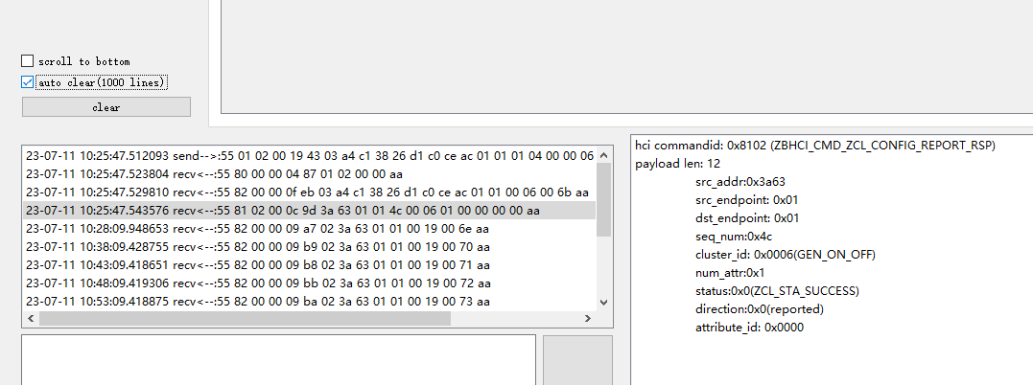

2). The “HCI OTA” is used to download the OTA file of the other devices. The gateway will save the file in its flash. Then upgrade the other devices through Zigbee OTA messages.

